Title: | Window lifter  SW Component < XXXXXXX >

History
Issue status  (Index) | Maturity/Date  (draft/invalid/valid)  (dd-mmm-yyyy) | Author  Department | Check/Release  Department | Description
1.0 | Draft  04-0ct-09 | Ricardo Guerra | Ricardo Guerra | Creation of the document

Table of Contents
1 Purpose 3
2 Definitions and abbreviations 3
3 Realization constraints and targets 3
4 SW Conceptual design 3
5 SW Component internal breakdown 4
5.1 Functional Decomposition 4
5.2 Function <Type> <function name> (type par 1, .., type par n) 5
5.3 Function <Type> <function name> (type par 1, .., type par n) 5

Purpose
This is a didactical project to improve our skills doing the corresponding documentation and programming for a project

Definitions and abbreviations
Definitions

Abbreviations
STM System Timer Module
GPIO General Purpose Input Output
References
N° | Document name | Reference
1 | Window lifter requirements
2 | MPC5607BRM

Realization constraints and targets

The project must be able to close and open a window using two buttons to select the direction and the working mode. It consist on two working modes: the automatic mode must close or open the window totally without interruption. The manual mode should close and open the window keeping pressed the corresponding button, having different levels.
The window level must be display on ten red leds. An antipinch function must be include to prevent accidents. If the window is closing the antipinch function will stop the up movement and open completely the window.

SW Conceptual design
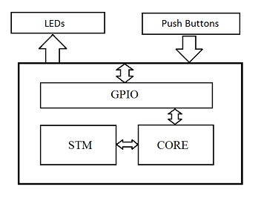

SW Component internal breakdown

Functional Decomposition
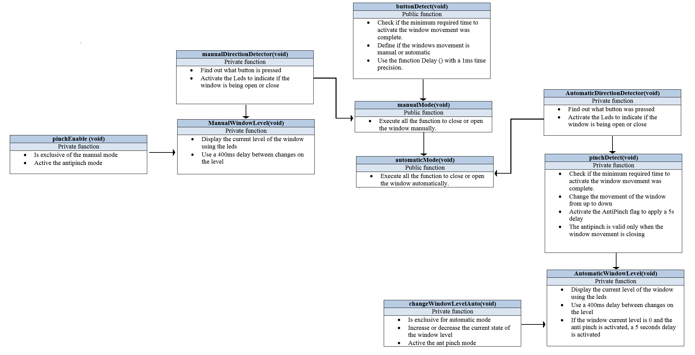
Function Description and Dynamic Behavior

Function void SetPTAOut(void )

Description | Enable the pins from port A as output
Parameter 1 | void
Return Value | void
Precondition | e.g. specific State change e.g. car is locked, EEPROM Values written,Relation between output parameters where applicable

Function void initModesAndClock (void)
Description | Enable the modes and clocks needed to work
Parameter 1 | void
Return Value | void
Precondition | e.g. specific State change e.g. car is locked, EEPROM Values written,Relation between output parameters where applicable
Dynamic Behavior

Function void disableWatchdog (void)
Description | Disable the watchdog function
Parameter 1 | void
Return Value | void
Precondition
Dynamic Behavior

Function void initPeriClkGen (void)
Description | Enable the system's clock needed
Parameter 1 | void
Return Value | void
Precondition
Dynamic Behavior

Function Void initEMIOS_0 (void)
Description | Enable the channel 0 and register to use the internal timer STM
Parameter 1 | void
Return Value | void
Precondition | STM is initialized

Function Void Delay (int16_t time)
Description | Produce a delay with a one milisecond base
Parameter 1 | Input int16_t time
Return Value | void
Precondition | The function can only be used after the internal timer is setted
Dynamic Behavior

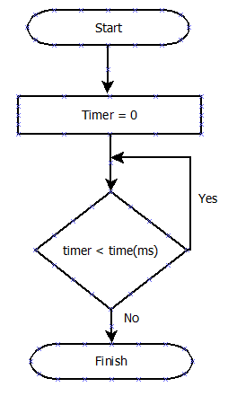

Function Void pinchDetect (void)
Description | Detect the minimum required time to activate the anti pinch function
Parameter 1 | void
Return Value | void
Precondition | a push button must be assign to simulate the anti pinch
Dynamic Behavior
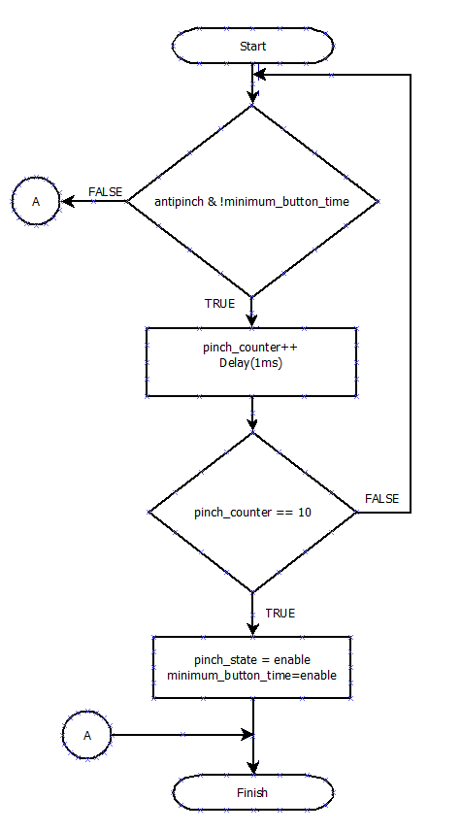

Function Void automaticDirectionDetector (void)
Description | Find out what is the direction of the window in automatic mode
Parameter 1 | void
Return Value | void
Precondition | The automatic mode must be called first

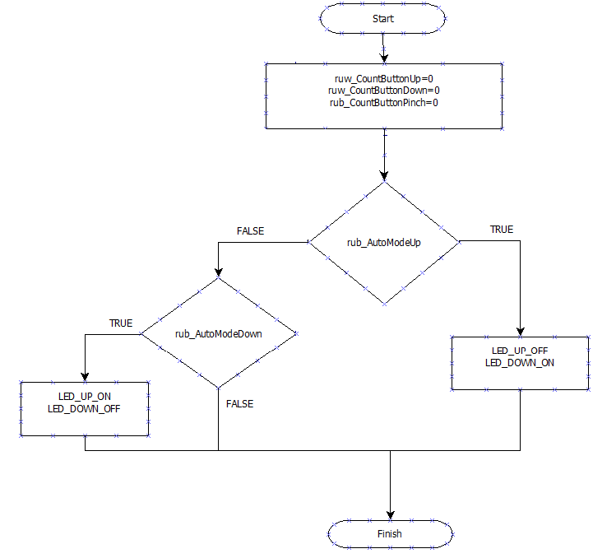

Function Void manualDirectionDetector (void)
Description | Find out what is the current direction of the window movement in manual mode
Parameter 1 | void
Return Value | void
Precondition | The manual mode must be called first

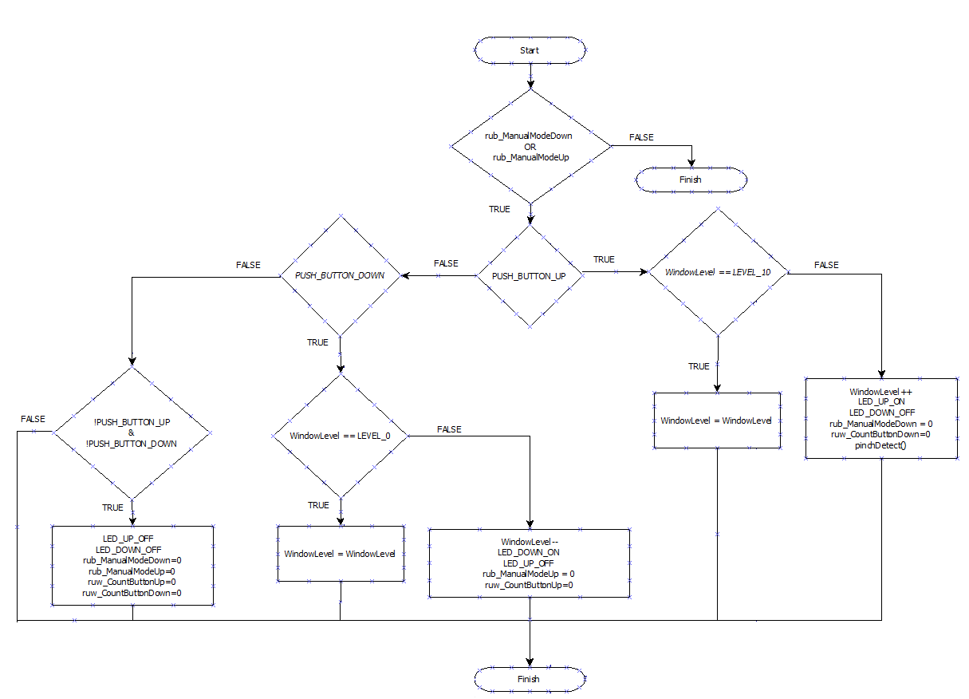

Function Void manualWindowLevel (void)

Description | Change the level of the window manually
Parameter 1 | void
Return Value | void
Precondition
Post condition

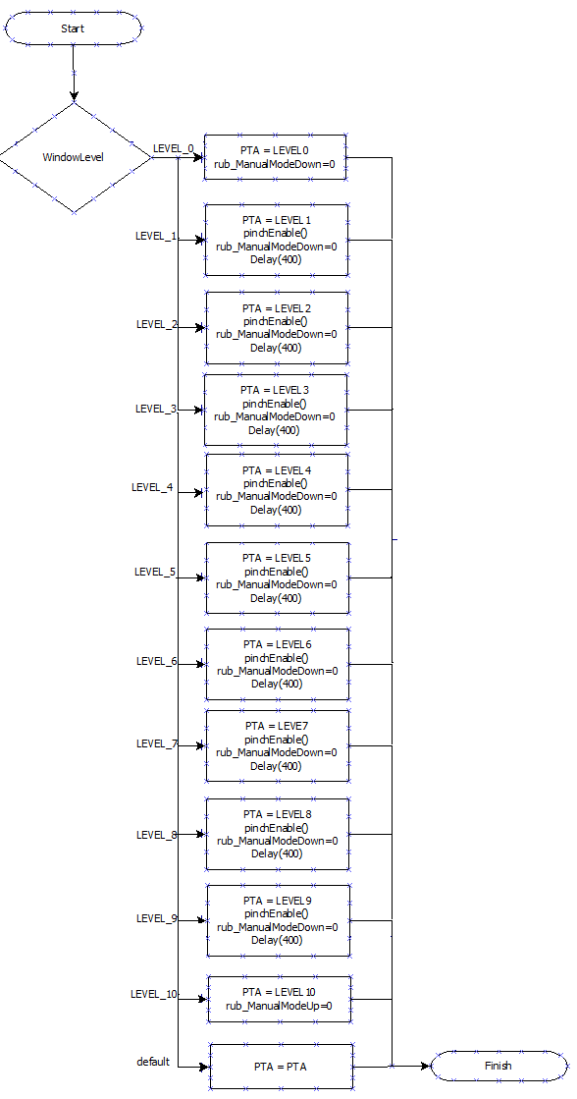

Function Void automaticWindowLevel (void)

Description | Change the current level of the window in automatic mode
Parameter 1 | void
Return Value | void
Precondition
Post condition

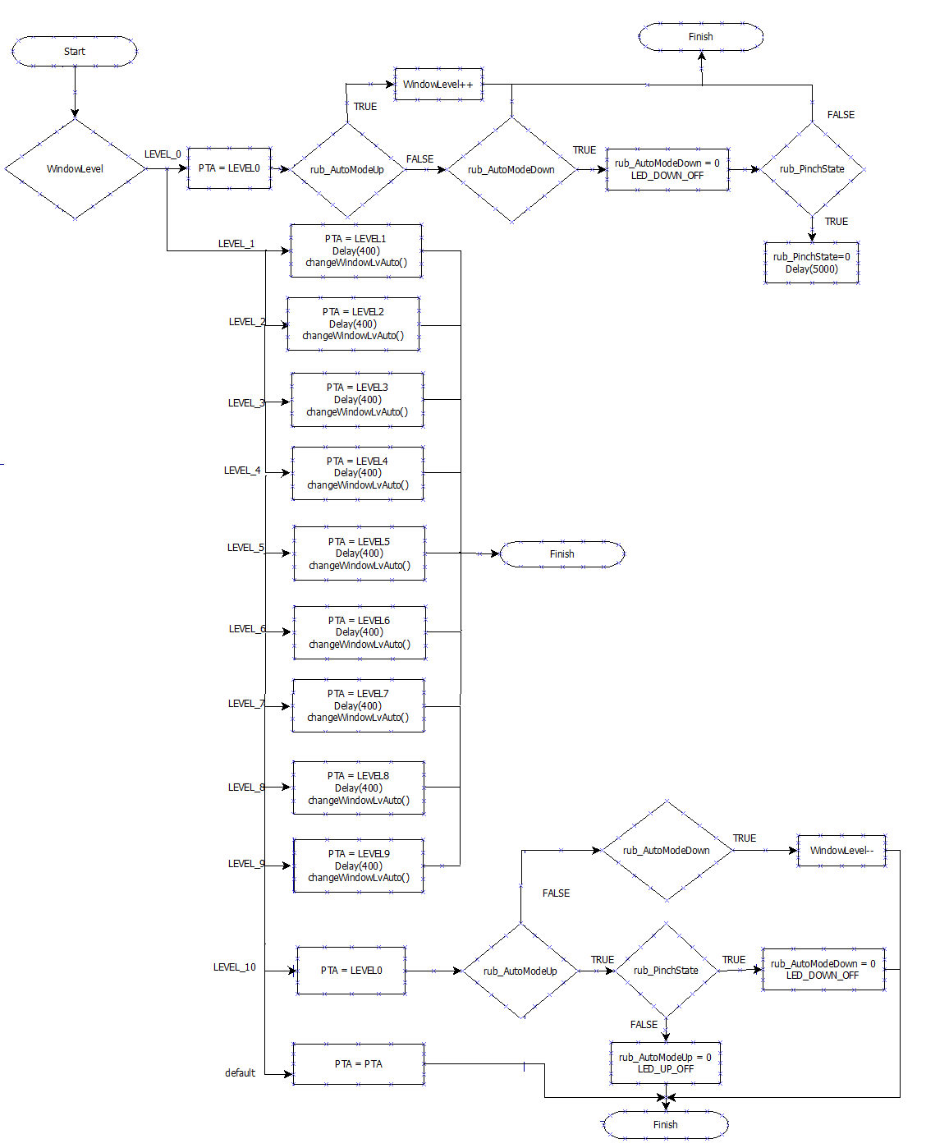

Function Void pinchEnable (void)
Description | active the antipinch function in manual mode
Parameter 1 | void
Return Value | void
Precondition
Post condition

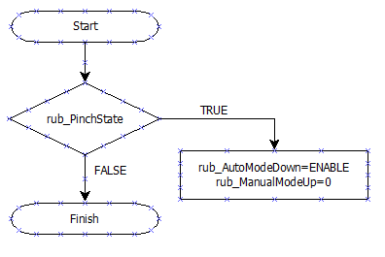

Function Void changeWindowLevel (void)
Description | Change the current level of the window in auto mode
Parameter 1 | void
Return Value | void
Precondition | Is accessible only in automatic mode
Post condition

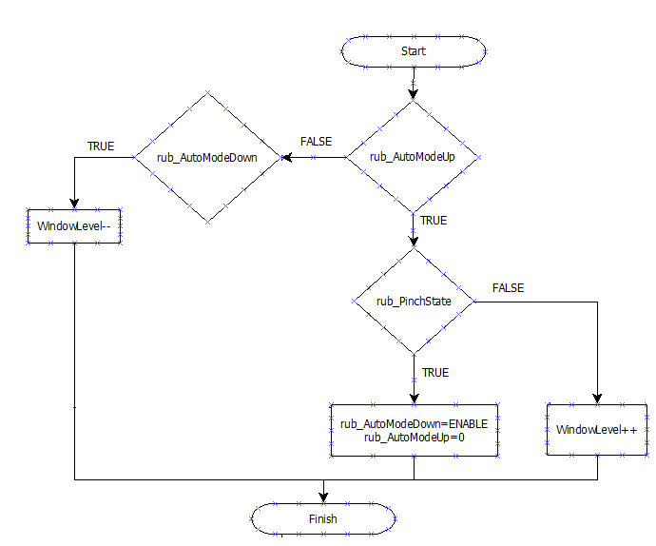

Function Void buttonDetect (void)
Description | Detect the minimun required time to activate the window movement and what is the mode of work selected
Parameter 1 | void
Return Value | void
Precondition
Post condition

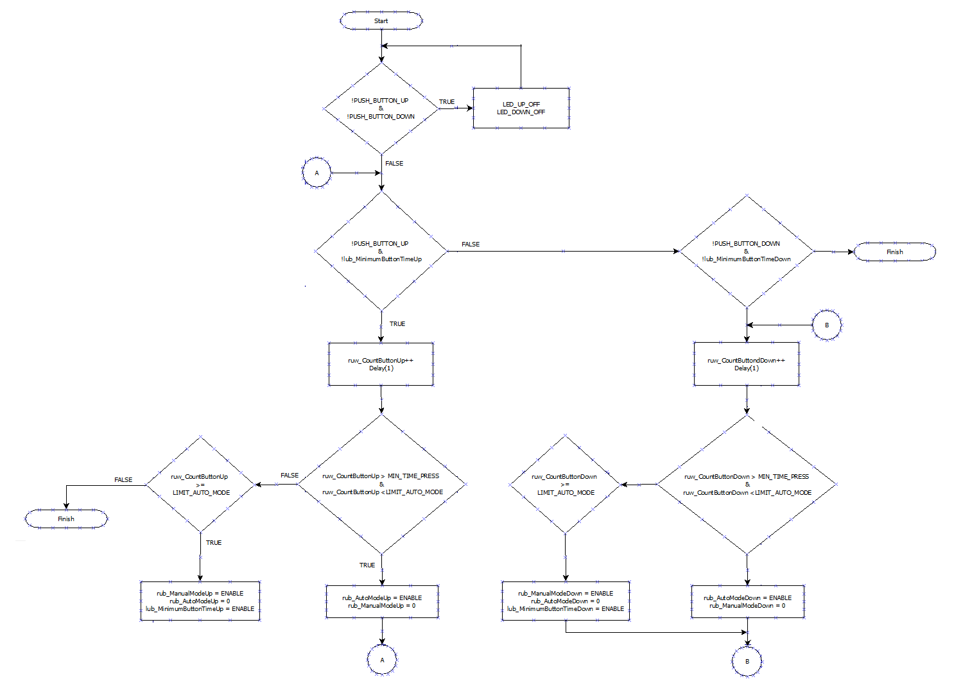

Function Void manualMode (void)
Description | Close and open the window manually
Parameter 1 | void
Return Value | void
Precondition | depends of the buttonDetect function
Post condition

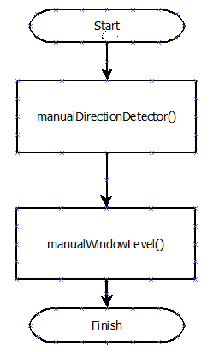

Function Void automaticMode (void)

Description | Close and open the window automatically
Parameter 1 | void
Return Value | void
Precondition | depends of the buttonDetect function
Post condition

